CURRICULUM VITAE
Full Name  Place/Date of Birth  Sex  Address  Cellphone  E-mail | : SATRIA JAYA  : JAKARTA, NOVEMBER 30, 1977  : Male  : Taman Wisma Asri Blok C 34 No. 11  Jl. Nangka 3 RT 003/016  Bekasi Utara 17121  : 0817 78 99 40 / 081286283447  : jaya_satria@yahoo.co.id | 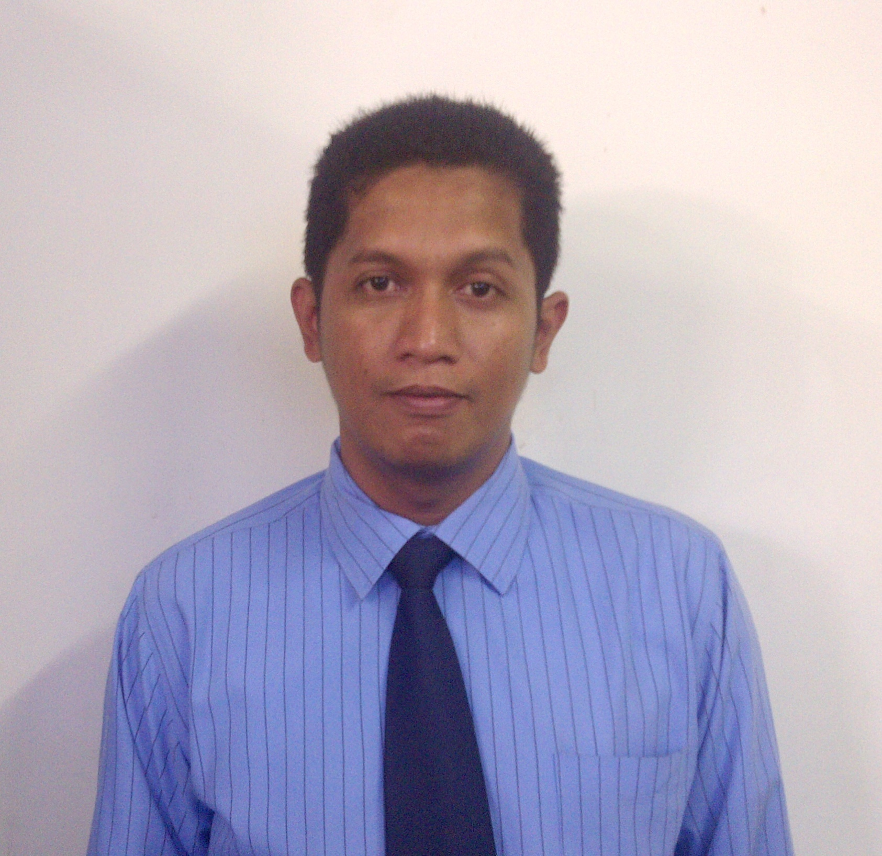

EDUCATIONS:
1993 - 1996 : Graduated from SMAN 62 Jakarta
1996 - 1998 : Graduated from LP3I (Jakarta) majoring Tour & Tourism Business (D2)

WORKING EXPERIENCES:
2000 – 2001 : Staff data entry
2001 – 2003 : Staff purchasing
2003 – 2007 : Supervisor purchasing
2007 – 2013 : Supervisor purchasing and General Affair ( GA)
2013 – Present : Supervisor purchasing and CSI

Spv. Purchasing And CSI
PT. Garuda Karya Mandiri, Jakarta

Major assignments :
- Handle purchasing stuff
- Locate vendors of materials, equipment or supplies, and interview them in order to determine product availability and terms of sales.
- Prepare and process requisition and purchase orders for supplies and equipment.
- Procurement and purchasing reports weekly and monthly
- Control purchasing department budgets.
- Resolve vendor or contractor grievances, and claims against suppliers.
- Prepare bid awards requiring board approval.
- Administer on-line purchasing systems.
- Conduct regular assessment to vendor every six month and one year.
- Lead the procurement team to set up the equipment on new project.
- communicating courteously with customers by telephone, email, letter and face to face
- negotiating contracts
- demonstrating/presenting products

PROFESSIONAL EXPERIENCE :
- Planning team members and Procurement of Engineering tools in Garuda Sentra Operasi cengkareng / GSO ( 2001 )
- Planning team members and Procurement of Housekeeping tools in Garuda Sentra Operasi Cengkareng / GSO ( 2001 )
- Planning and procurement of Trane Chiller repair in Garuda sentra Operasi Cengkareng / GSO ( 2002 )
- Planning team members and Procurement of Engineering tools in Terminal 1 PT.Angkasa pura cengkareng ( 2003 )
- Planning team members and Procurement of housekeeping tools in Terminal 1 PT.Angkasa pura cengkareng ( 2003 )
- Planning team leaders and Procurement of Engineering tools in Terminal 2 PT.Angkasa pura cengkareng ( 2003 )
- Planning team leaders and Procurement of Engineering tools in PT.PLN Trunojoyo Jakarta ( 2005 )
- Planning team leaders and Procurement of Engineering tools in Garuda Indonesia Maintenance Facility / GMF Cengkareng ( 2006 )
- Planning team members and Procurement of Engineering tools in Garuda Indonesia Training Centre / GITC Kosambi Jakarta Barat ( 2008 )
- Classroom renovation Team leaders Garuda Indonesia Training Centre / GITC Kosambi Jakarta Barat ( 2009)
- Planning team members and Procurement Chiller Mc.Quay 200 TR in GITC ( 2009 )
- Planning team members and Procurement Generator set in GITC ( 2012 )

PROFESSIONAL QUALIFICATION AND CERTIFICATION :
- Basic concepts of quality and introduction to ISO 9001 series
- ISO documentation system
- Service Excellent at Pusdiklat Garuda
- Quality Control management system ISO 9000 : 2000 Awareness Training at Pusdiklat Garuda
- English Course

ADDITIONAL SKILLS AND KNOWLEDGE :
- High proficiency in MS Office (MS Word, MS Excel, etc), and Internet

SELF DESCRIPTION :
- Honest, well organized and a self motivated worker which give me ability to working as a team or independently.

